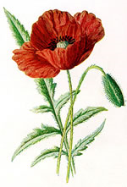Anzac Day 2018 – Wednesday April 25

On Anzac Day we will participate in the Greensborough Anzac Day March (this is the one attended by most Banyule District Scout Groups). FULL Uniform to be worn (white scarf for Cub New Chums!). Note that this is for Cubs and for any Scouts/Venturers/Rovers not helping with the March in the City.

Anzac Day March
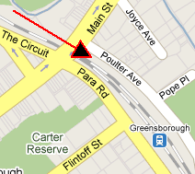
We’re participating in the Greensborough march. Meet at the carpark off Poulter Ave (opposite Greensborough RSL), Greensborough - Melway Map 20 K1

Be there before 8.30am to get ready for the start.

The March will proceed up the hill to Memorial Park in Henry Street for the Anzac Service. Refreshments will be provided for all at Greensborough R.S.L. afterwards.

Remember: On top of the significance of Anzac Day for us, participation in a Service is also part of the Heritage Badge (‘Their Service, Our Heritage’). If you take part in another Anzac Day service (preferably in Uniform), please let us know so your attendance can still count.

Queries? Contact: Akela 0411 121 495 - akela@rosannacubs.org

